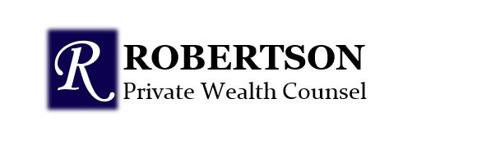
Managing Through Covid 19

We would like to thank all our clients for their patience, while we work through these times. Truly an unbelievable period to be living through. We have had a few calls, and some of our calls have been to offer encouragement and understanding; and we are so grateful. Yes, we had calls on markets and we are happy to speak with our clients and to hear your concerns and offer our guidance.

There are so many aphorisms that come to mind, such as; “You can only walk so far into the woods because after half way you start to walk out again.” So many, but few, match the truth of this aphorism, “The shortest distance between two points is always under construction.”

We are challenged by these concerning times and challenged by client’s thoughts. The unfolding of these times is not that unusual, to us, we’ve experienced many situations over 30 years and we will be here to give our best advice to our clients and staff. It is our job to focus on a long-term strategy to actively manage risk; by monitoring both opportunity and risk and to personally care about managing the current situation.

We know that our clients are not (always) interested in the price of oil, the reduction in interest rates, the health of economic activity, or travel or tourism. We understand most people are glad when things are rising and unsettled as times are tough, but we also understand that it is extremely important that we are handy when you need rationalization. During times like this you will see the benefit of a well structured diversified portfolio comprised of managed funds with experienced Fund Managers who will take the necessary steps to manage risk and find opportunities and we will see the outcome of that work, especially when the markets recover.
The recovery will take time and so it’s important to be reminded of your long term goals and trust in the advice we offer. We have a highly-trained team to help us serve you.

We are here to answer your calls, discuss your concerns and guide you through to the recovery that is sure to come.

Dixi Robertson, CFP®,FMA,CIM®
Portfolio Manager
Director, Private Client Group
HollisWealth, a division of Industrial Alliance Securities Inc.

This information has been prepared by Dixi Robertson who is a Portfolio Manager for HollisWealth® and does not necessarily reflect the opinion of HollisWealth. The information contained in this correspondence comes from sources we believe reliable, but we cannot guarantee its accuracy or reliability. The opinions expressed are based on an analysis and interpretation dating from the date of publication and are subject to change without notice. Furthermore, they do not constitute an offer or solicitation to buy or sell any of the securities mentioned. The information contained herein may not apply to all types of investors. The Portfolio Manager can open accounts only in the provinces in which they are registered.
HollisWealth® is a division of Industrial Alliance Securities Inc., a member of the Canadian Investor Protection Fund and the Investment Industry Regulatory Organization of Canada.

